SIMATS ENGINEERING
ASSESSMENT TOOL 3 – COMPLETED CASE STUDY
COURSE NAME: INTERNET PROGRAMMING | COURSE CODE: CSA43
COURSE OUTCOME COVERED
CO-1: Develop well-structured, standards-compliant web pages using HTML/XHTML and XML, and apply Internet protocols and HTTP communication mechanisms for web content delivery (L2).
Assessment Tool: Case Study | Weightage: 10% | Total Marks: 10
Student Name: N. Sai Preethika Register Number: 192372344

Scenario: Web Development Standards Implementation

The startup needs to embed a promotional video, submit registration data securely, use semantic navigation, correct XML syntax errors, and communicate through the appropriate web protocol. The following answers select and justify the best options from the supplied snippets.

1. Correct HTML Tag for Video Embedding

1. Select the correct HTML tag for video embedding and justify your answer.

Correct option: B — <video src="video.mp4" controls></video>. The HTML5 <video> element embeds video content. The src attribute identifies the file, and controls provides built-in playback controls such as play, pause, and volume. The options <media>, <movie>, and <vid> are not standard HTML elements for embedding video. Multiple source formats and fallback text can improve compatibility.
<video controls>
<source src="video.mp4" type="video/mp4">
Your browser does not support the video element.
</video>
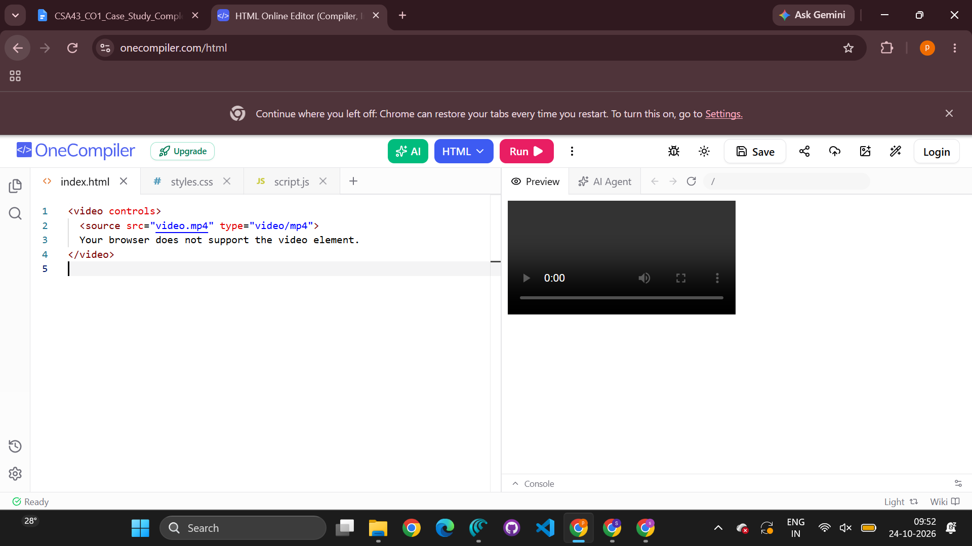

2. Appropriate HTTP Method for Form Submission

2. Identify the appropriate HTTP method for form submission and explain why.

Correct option: B — POST. A registration form submits user-provided information to the server, and POST sends form data in the request body instead of appending it to the URL as GET normally does. This is more appropriate for registration data and avoids exposing values in the query string. POST alone does not encrypt information; HTTPS and server-side validation are still required. GET is generally used to retrieve resources, while PUT and DELETE are commonly used for resource updates and deletion in APIs.
<form action="/register" method="post">
<label for="name">Full name:</label>
<input id="name" name="name" type="text" required>
<label for="email">Email:</label>
<input id="email" name="email" type="email" required>
<button type="submit">Register</button>
</form>
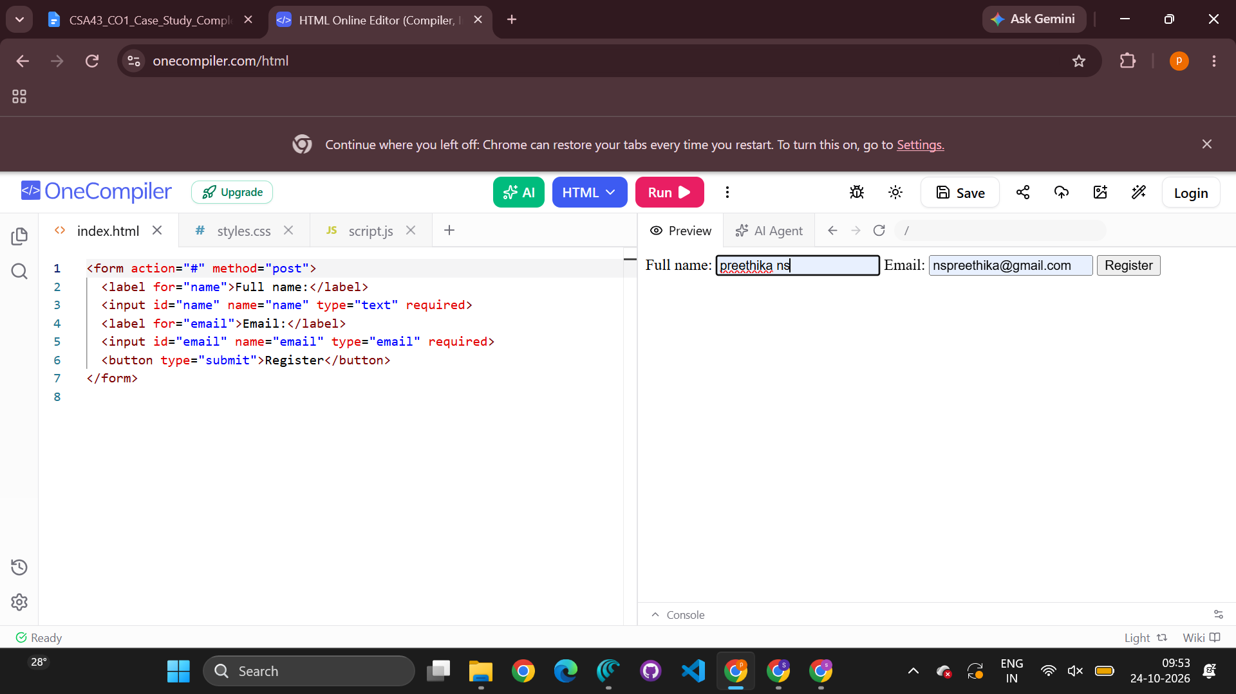

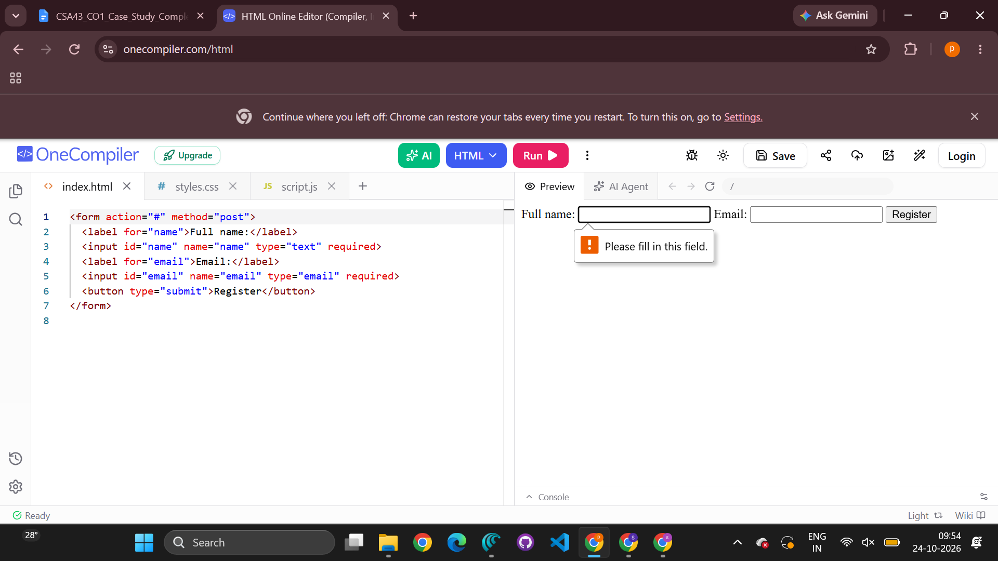

3. Proper Semantic Element for Navigation

3. Choose the proper semantic element for navigation and justify its usage.
Correct option: B — <nav>. The <nav> element identifies a major group of navigation links, such as links to Home, Events, and Contact. It communicates the region's purpose to browsers, developers, and assistive technologies. A <div> is generic; <section> groups thematically related content; and <header> contains introductory content or aids but does not specifically replace <nav>.
<nav aria-label="Main navigation">
<ul>
<li><a href="index.html">Home</a></li>
<li><a href="events.html">Events</a></li>
<li><a href="contact.html">Contact</a></li>
</ul>
</nav>
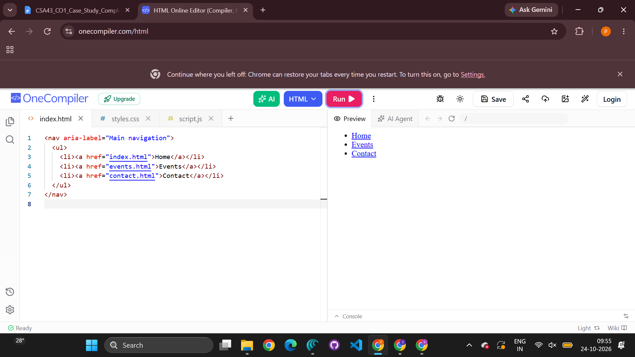

4. Correct XML Syntax

4. Identify the correct XML syntax and explain the error in other options.

Correct option: B — <note><to>User</to><from>Admin</from></note>. It is well-formed XML because it has one root element (<note>), matching start and end tags, and properly nested elements. Option A is incomplete because the <note> root is not closed. Option C mismatches the tags by closing <to> with </from> and does not close the elements correctly. Option D is incomplete because the closing angle bracket is missing from </note>. XML is case-sensitive and requires matching, properly nested tags.
<?xml version="1.0" encoding="UTF-8"?>
<note>
<to>User</to>
<from>Admin</from>
</note>
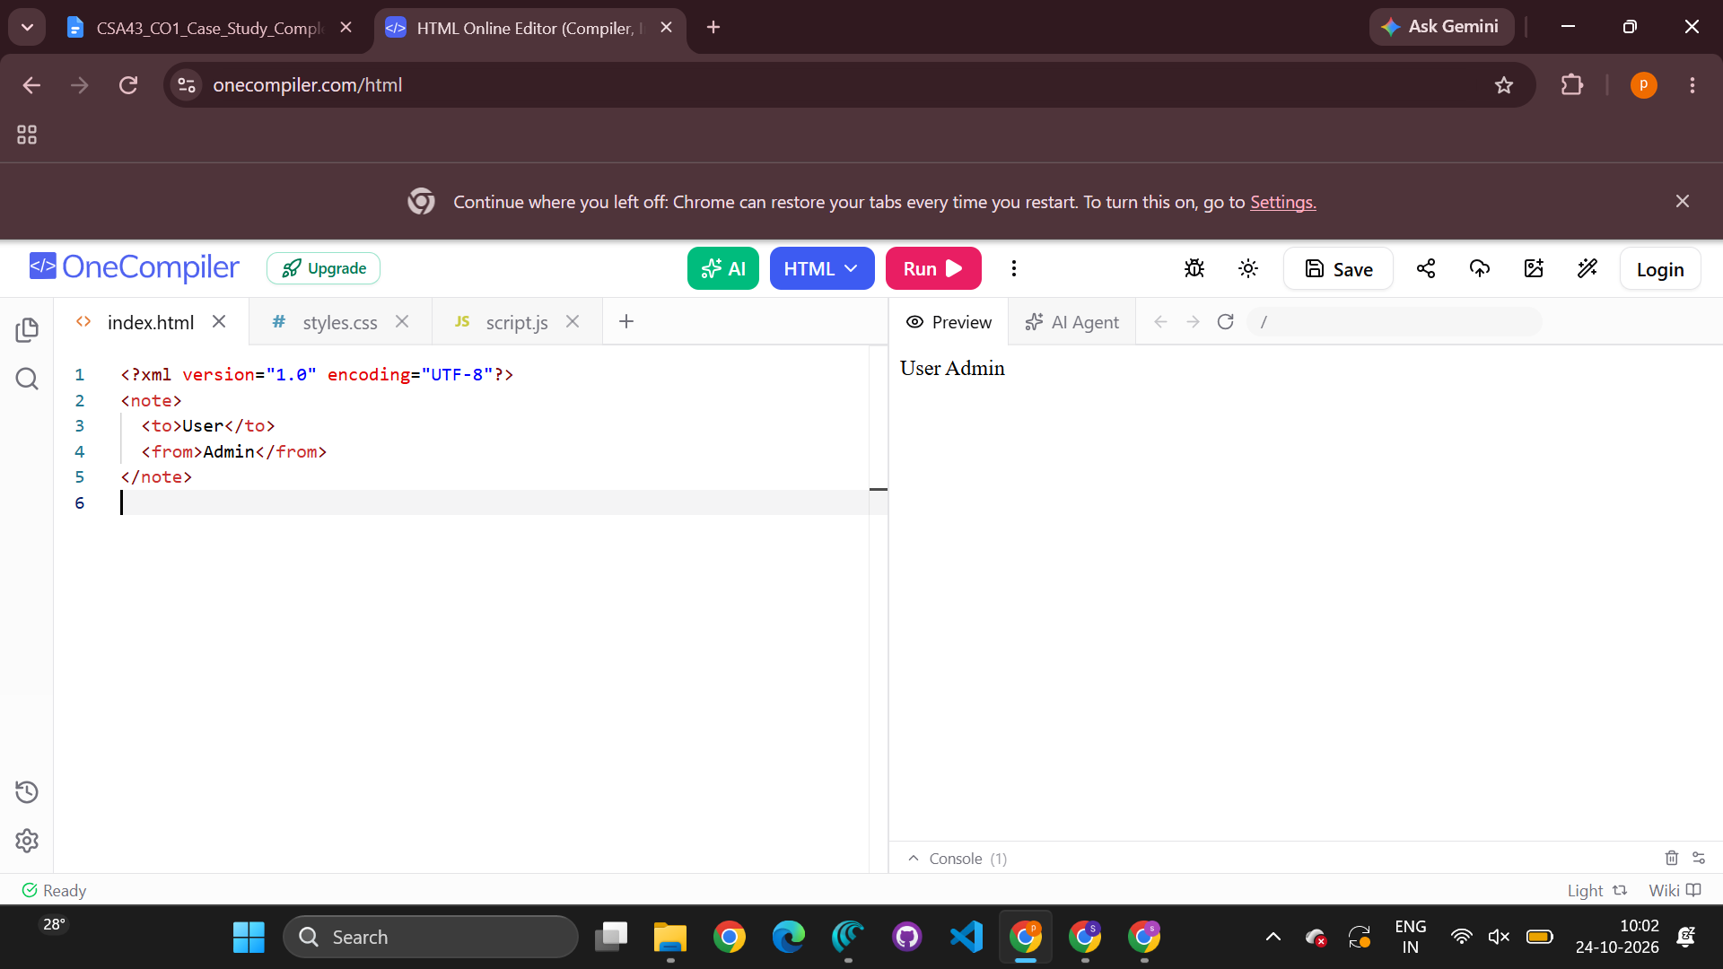

5. Correct Protocol for Web Communication

5. Choose the correct protocol for web communication and justify your choice.

Correct option: B — HTTP. Hypertext Transfer Protocol is the application-layer protocol used for communication between web clients, such as browsers, and web servers. It defines requests and responses for transferring web resources. In real deployments, HTTPS is preferred because it uses TLS to encrypt HTTP communication and authenticate the server. FTP is designed for file transfer, SMTP for sending email, and SNMP for network management.
Practical recommendation: Use HTTPS, submit registration data with POST, validate all inputs on the server, and keep HTML markup and XML configuration files well-formed and standards-compliant.

Conclusion
The correct choices are the HTML5 <video> element, POST for registration submission, <nav> for primary navigation, option B for well-formed XML, and HTTP for web communication. These choices follow web standards and provide a sound basis for a reliable application. For secure deployment, use HTTP over TLS as HTTPS, and validate and protect sensitive form data on the server.

Code of Conduct
I N. Sai Preethika/192372344 (Name / Register Number) certify that this submission is my original work and that I have adhered to the guidelines specified for this assessment. I understand that any violation of academic integrity rules will result in disciplinary action.
Signature of the student: preethika

